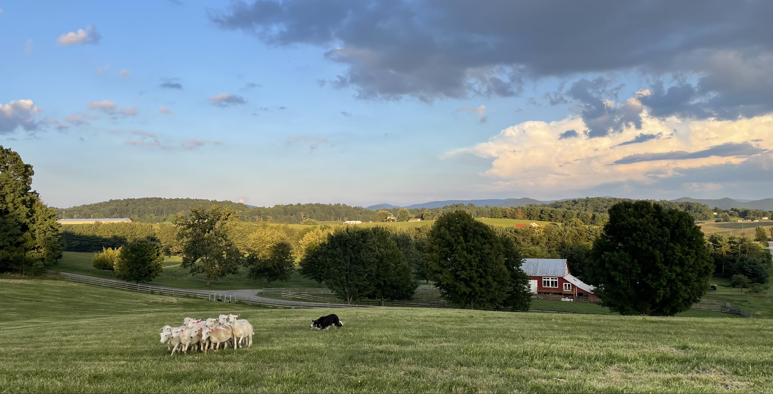

2024 Jack Knox Spring Clinic at Red Gate Farm
APRIL 26-28

.
**The clinic will be limited to 16 working spots per Jacks request
This will be reflected in the cost of the clinic. Lunch will be included for each working spot registrant. 5.00 per person that is not a working spot registrant.
Coffee and muffins and fruit will be provided for breakfast and we will provide a soup and sandwich type lunch.
Mail Entries /Make Checks Payable to:
Nellie Bierly
60 Red Gate Lane
Fairfield , Virginia 24435

You can also pay by Venmo: nellie bierly @nellie-bierly

We have spots for campers and a limited number of hookups, so please let us know ahead of time if you are bringing a camper and will need a hookup. We have fields to accommodate all levels from round pen to 400 yard outruns.

We have free ranging chickens and cats in additon to horses and cattle so please manage dogs accordingly . Please keep your dog leashed around the barns and buildings where these animals tend to hang out. Please also remember there is no video taping of any kind allowed at the clinic.

Registrations without payment will not be accepted. If you need additional entry forms please e-mail me at Nellie@ntelos.net. Cost for three days is $325.00. A lunch will be provided each day..

Cancellations after, April 1 will be given a refund only if someone fills your spot..

Auditors are welcome and can show up without registration, however, if you can, please let me know if you plan to audit so we can have a head count for lunch. Nellie.bierly@gmail.com . Auditing fee is 15.00 per day.

If you have questions please feel free to contact me.

How to find Red Gate Farm:

81 south to exit 200 right at the bottom of the exit. Turn right onto Sterrett lane
81 north travelers take exit 200 but turn left at the bottom of the exit onto Sterrett Lane
Follow Sterrett Lane about one mile until you see a VDOT center on the left. Turn Left just past onto Swope Lane. Follow Swope lane for about one mile and look for a big red barn with white trimmed windows on your right. Turn onto Red gate Lane and come down to the farm.
Nearby Hotels: Howard Johnson (Pet Friendly good dog walks) 1-866-6393 & Quality Inn Suites (Pet Friendly) 1-866-295-5798, both are about 7 miles away. Here are a couple of cabins/airbnb not too far away. Some people stay in Staunton which is 22 miles north of us. Lots of options there too.
http://www.lazyacrescabins.com/default.php
Here are some Airbnb options. Go online and check them out if you are interested. This is last years posting.. there may be new places so have a look. 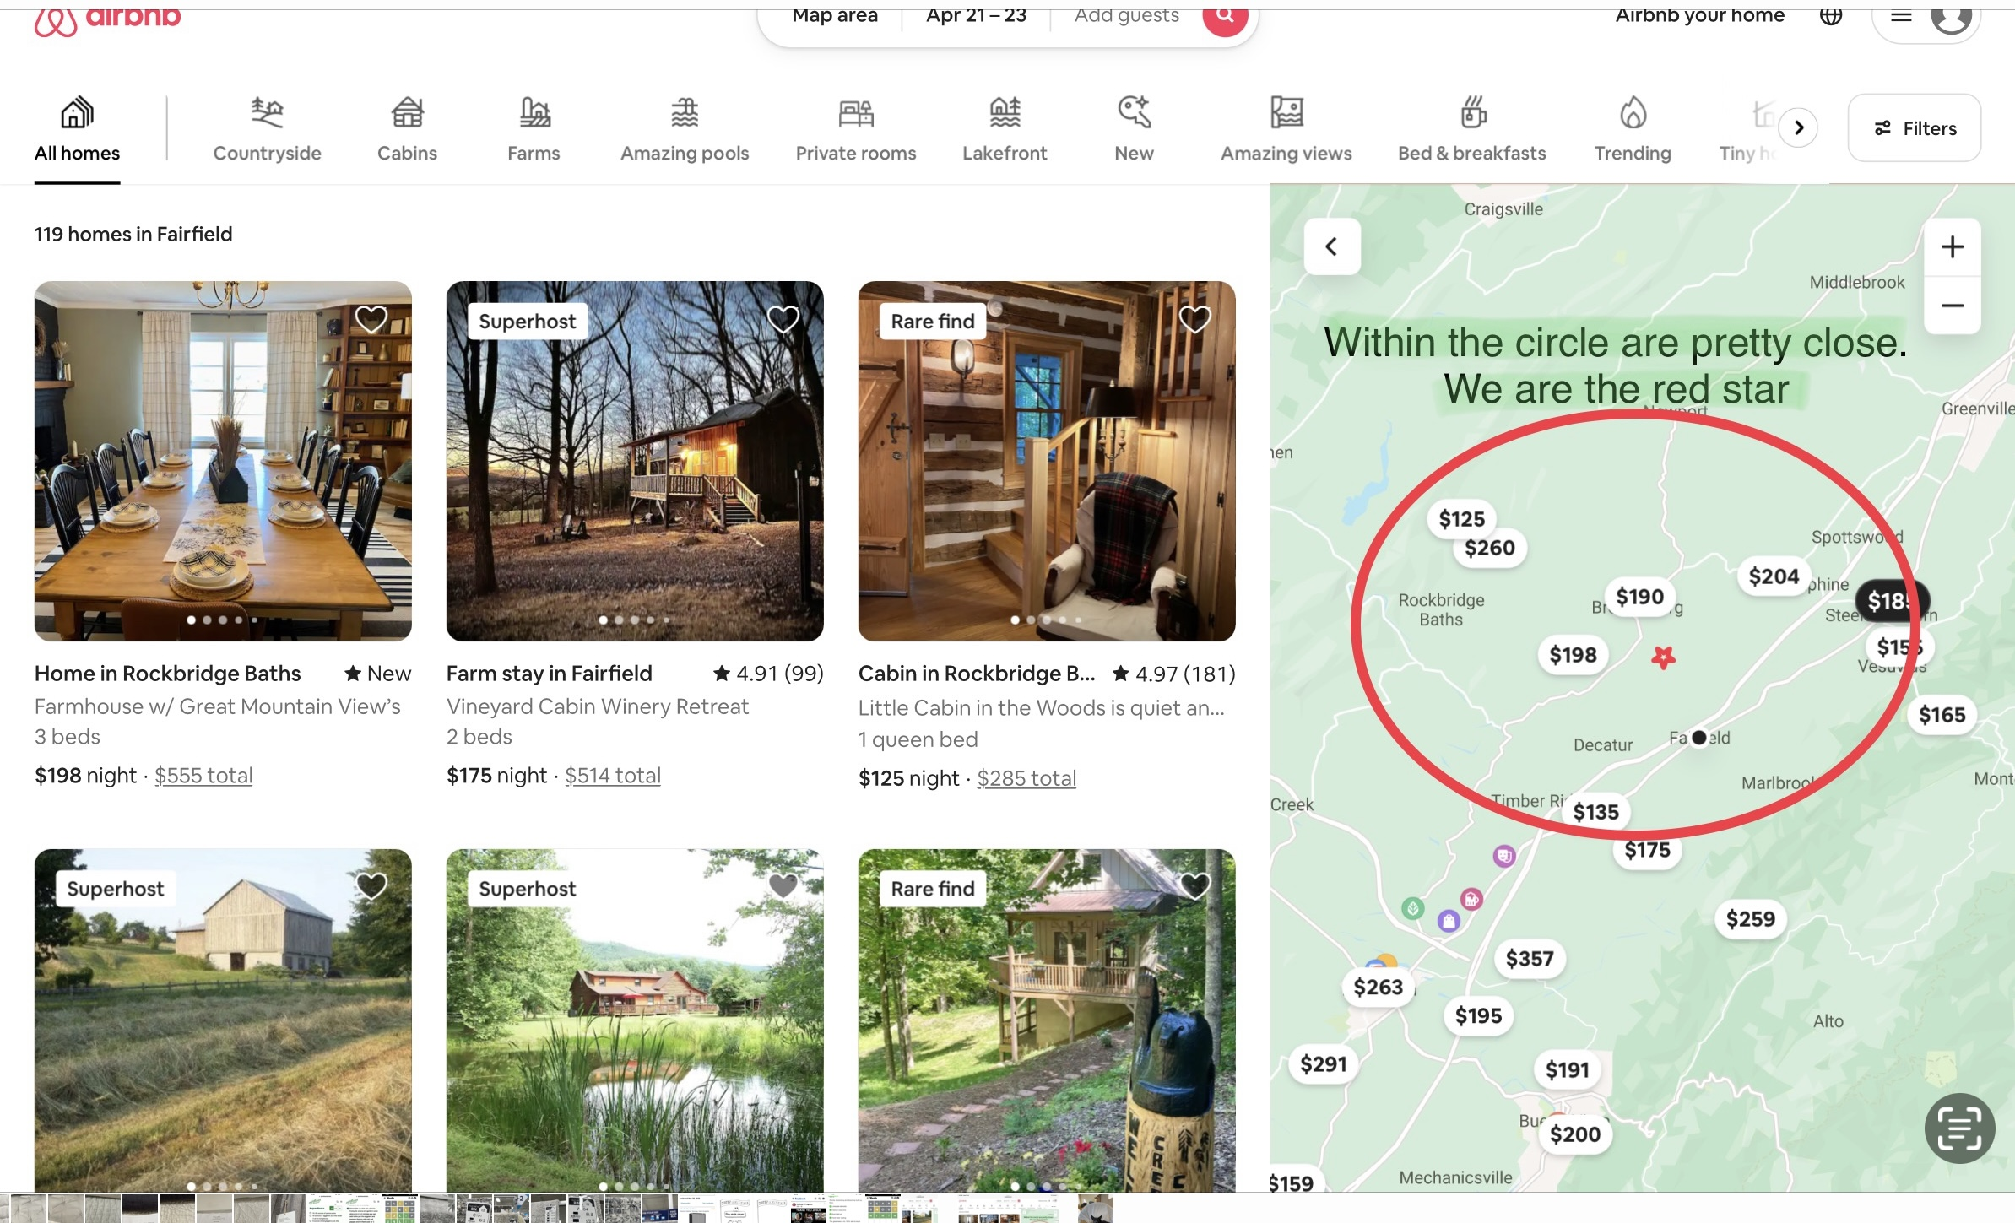

Jack Knox Handler’s Clinic
April 26,27,28
Red Gate Farm, Fairfield,VA

Name: _____________________________

First dog:________________ Age _____ Level* ____
Dog Sire:______________
Dog Dam:______________

Second dog:______________ Age ____ Level* ____
Dog Sire:______________
Dog Dam:______________

3 Day $325.00_________
Audit 15.00/day _______
Have you ever attended a Jack Knox Clinic Before?
*Dog Level ( Round Pen, Small Field or Large Field) Leave Blank if you are not sure, Jack can place dogs where he feels best, this is just so we have an idea of how many dogs we have where.

I understand that attendance at and participation in a sheep dog training clinic is not without risk to myself, members of my family or guests who may attend, or my dogs, because some dogs and other animals to which I will be exposed may be difficult to control and may be the cause of injury or illness even when handled with the greatest amount of care.
I herby waive and release the owners and operators of Red Gate Farm, the clinic instructor, hereinafter referred to as the “Training Organization”, its employees, officers, members and agents from any and all liability of any nature, for injury or damage which I or my dog (s) my suffer, including specifically, but with out limitation, any injury or damage resulting from the action of any dog or other animal, and I expressly assume the risk of such damage or injury while attending any training session, or any other function of the Training Organization, or while on the grounds or surrounding area thereto.
In consideration of and as a inducement to the acceptance of my application for training by this Training Organization, I herby agree to indemnify and hold harmless this Training Organization, its employees, officers, members, and agents, from any and all claims by any members of my family or any other persons accompanying me to any training session or function of the Training Organization, or while on the grounds or the surrounding area thereto as a result of any action by any dog or other animal including my own.
Signature of Owner or Authorized Agent (In case of a minor a parent or legal guardian must sign)& Date
Signature:__________________________________
Date: ______________________________________
Address ___________________________________
Phone:______________________
E-Mail: __________________________________

